Simplified Docker Installation process in Windows

## **Step 1: Make sure the Virtualization is enabled**

The first thing to do is to make sure virtualization tool is available and enabled , to check it, just right click on the Taskbar of Windows and select **Task Manager**->**Perfromance** and see the **Virtualization** value.

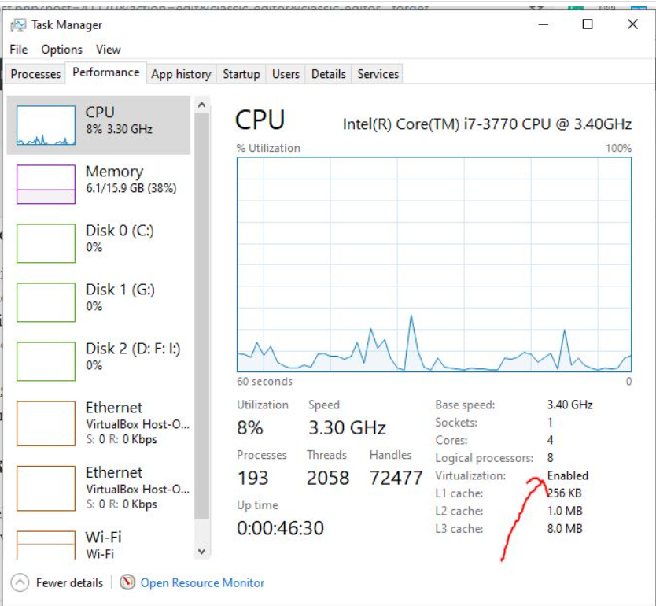

### **Step 2: Checking for Admin privileges**

This can be done in different ways;

1. Using the Settings app

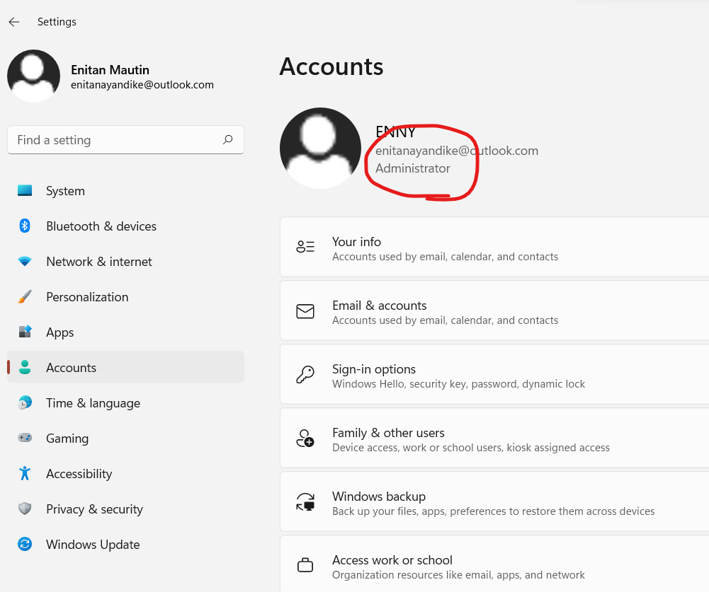

### **2. Using PowerShell**

This is simplier way to find out administrator account , first open Powershell through search box and enter the following command:

net localgroup administrators

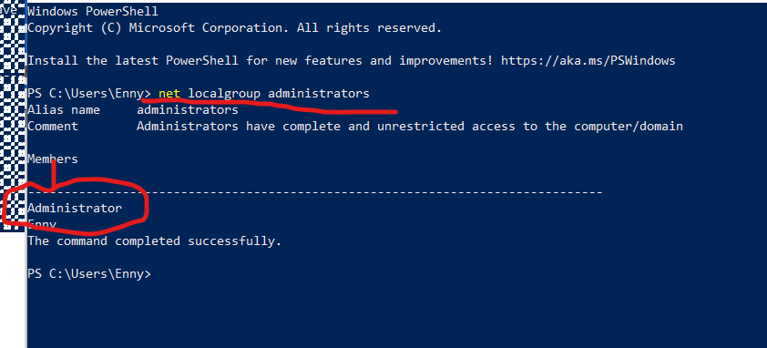

## **Step 3: Run .bat script on Cmd**

This file will run both chocolate package and Docker on your system.

[**https://hameenamk.sharepoint.com/:u:/s/ICT_Project_2021/EW_h1O18z9FGtRS2Ch1wwKIBKb2O-ZAfMQZ6TwOJRN3aWA?e=V19MFQ**](https://hameenamk.sharepoint.com/:u:/s/ICT_Project_2021/EW_h1O18z9FGtRS2Ch1wwKIBKb2O-ZAfMQZ6TwOJRN3aWA?e=V19MFQ)

You can check the version

Choco –v

Docker –v

**Step to Uninstall**

With the below link both Choco package and Docker can be uninstalled by pasting the below link in the Cmd promt usimg admistrative right:

[**https://hameenamk.sharepoint.com/:u:/s/ICT_Project_2021/EZ5Giit2j19Hhlwt1d0ZkJQB4NSMC9yo1EGYkmuevSwRpg?e=6LOBSl**](https://hameenamk.sharepoint.com/:u:/s/ICT_Project_2021/EZ5Giit2j19Hhlwt1d0ZkJQB4NSMC9yo1EGYkmuevSwRpg?e=6LOBSl)

Reference

<https://www.how2shout.com/how-to/how-to-install-docker-toolbox-using-chocolatey-choco-on-windows-10.html>

## <https://howchoo.com/chocolatey/use-chocolatey-and-batch-file-to-automatically-install-pc-programs>

<https://howchoo.com/chocolatey/use-chocolatey-and-batch-file-to-automatically-install-pc-programs>

<https://www.how2shout.com/how-to/how-to-install-docker-toolbox-using-chocolatey-choco-on-windows-10.html>

https://www.thewindowsclub.com/how-to-check-if-a-user-account-is-an-administrator